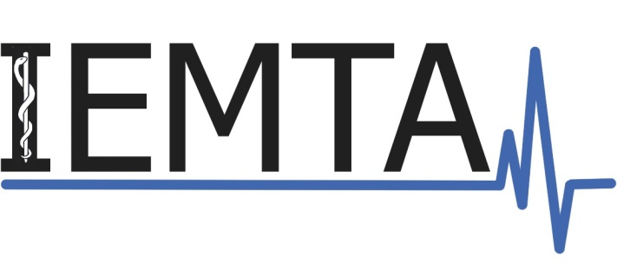

IEMTA 2017
SPRING SCIENTIFIC MEETING OF
THE Irish eMERGENCY Medicine TRAINEES Association

Royal College of Surgeons Ireland, Dublin 2.

Friday 28th April 2017

ABSTRACT FORM

TITLE OF PAPER:

*Author(s) Title (Dr, Mr, etc), Professional Grade/ Student and Hospital/ University (underline name of presenter)

MAILING ADDRESS:

Email:
Telephone:

My preferred format for the presentation of this abstract is (please circle):

ORAL POSTER

Name of PRINCIPAL AUTHOR:

Date:

When completed, abstract forms should be emailed to iemtaspring2017@gmail.com
Please use your surname followed by the word ‘abstract’ as the subject heading for the email

Abstract forms must be received by the deadline of 17.00 hours on 7th April 2017

Abstracts will be judged by their scientific validity, importance, and relevance to Emergency Medicine. Abstracts are welcome from medical students and doctors with an interest in Emergency Medicine. Authors will receive notification of acceptance by the 14th April 2017. The authors of the highest rated abstracts submitted for oral presentation will be invited to give a lightening oral presentation. Other work will be invited in poster format.

Page 1/2
AUTHOR(S):
Affliated Emergency Department/ Hospital/ University:
EMAIL:

BODY OF ABSTRACT: The abstract must be typed single-spaced and include no more than 300 words. Do not use a type size smaller than 10pt. Do not change the size of the text box. Do not include references. One Table or Figure is acceptable.
TITLE

INTRODUCTION

METHODS

RESULTS

CONCLUSION
Page 2/2

